Optogait and Qualisys synchronization

The aim of this file is to present the methodology used to synchronize the systems and how this synchronization was used to put the information in common. It will also present the timing errors remaining after the synchronization and the effectiveness in the timing of events in healthy and pathological gaits.

1. **Bibliographic** **study**

Before trying to use the Optogait for event detection, its validity for clinical and research purpose needed to be assessed.

* 1. **Lienhard et al.: Validity of the Optogait photoelectric system for the assessment of spatiotemporal gait parameters**

In this publication [1] the validity of the Optogait was tested against an already validated electronic walkway, Gaitrite (CIR System Inc., Clifton, NJ, USA). To test the Optogait, 15 patients who had undergone unilateral total knee arthroplasty and 15 healthy patients walked at three different self-selected speeds (slow, normal and fast) along a 10m walkway. This walkway was instrumented with an Optogait system constituted by nine transmitting and nine receiving bars. The Gaitrite electronic mat contains a network of 13mm pressure sensors arranged over an area of 7.3m*0.6m. The total length and width of the mat was 8.4m*0.6m. The data was sampled at 80 Hz. A total of six parameters were used to assess the validity of the Optogait: walking speed, cadence, cycle time, stance time, swing time and step length.

All the variables used showed a high concurrent validity, with interclass correlation coefficient (ICC) from 0.933 to 0.999. The cycle time, the cadence and the walking speed reported the highest correlation, with an ICC of 0.999. Still systematic biases were observed: the cycle time and stance time were longer for Optogait than for Gaitrite. Cadence, walking speed and step length were lower.

In this study, the Optogait system demonstrated high discriminant and concurrent validity with the Gaitrite system. The systematic biases could be explained by the geometry of the Optogait. As the LEDs were 3mm from the ground, the Optogait system start measuring the stance phase some milliseconds before foot contact, while the Gaitrite identifies the contact at the exact moment, but it may be interesting to keep in mind that the pressure threshold used was not communicated by the constructor. For the same reason the foot off was detected later by the Optogait.

The findings of this publication corroborated the validity of the Optogait system against the Gaitrite system for the evaluation of spatiotemporal walking parameters. Plus the Optogait offers some advantages, such as a real portability and a quick set-up time, with 5 minutes to set up a 9 meter long walkway. This system was virtually usable on any flat surface. The price was relatively low, requires no maintenance or calibration, has little to no wear, the length and width were easily tuned.

The Optogait photoelectric system was considered valid for clinical and research use, with a reserve on the use for patient with no clearance in the swing phase as it was challenging for the Optogait system to identify events in this case.

* 1. **Lee et al. : Concurrent Validity and Test-retest Reliability of the OPTOGait Photoelectric Cell System for the Assessment of Spatio-temporal Parameters of the Gait of Young Adults**

In this publication [2], the test and re-test reliability of the Optogait was addressed, once again against the Gaitrite electronic mat. 20 young and healthy subjects walked three times across a 4 m long walkway at a comfortable speed.

The correlation between the Optogait and Gaitrite system was also high in this study, with the same systematic biases. To assess the test and re-test reliability, the first and third sessions were compared. No significant differences were encountered and the parameters between the two sessions showed a high level of correlation with an ICC within the range of 0.785 – 0.952.

* 1. **Shin et al. : Agreement between the spatio-temporal gait parameters from treadmill-based photoelectric cell and the instrumented treadmill system in healthy young adults and stroke patients**

For this work [3] the objective was to investigate the Optogait concurrent validity and test and re-test reliability against a treadmill based gait analysis system.

A total of 26 stroke patients and 18 healthy young adults participated to the study. These participants walked at a comfortable pace during 10 min on a treadmill without aids. A second test was made 30 min after the first one to evaluate the test-retest variability. The treadmill was instrumented with a Zebris capacitance-based foot pressure platform (Zebris Medical GmbH, FDM-T system, Isny, Germany). It has a sensing area of 112*49cm were 3432 sensors were incorporated. The sample rate was of 100 Hz. The parameters used were the walking speed, cadence, gait cycle, step length, step time, stride length, duration of single and double limb support, and swing and stance phase duration.

Concerning the results, the systematics biases found in the publication described above were once again present, with a shorter swing phase and a longer stance phase. Except for the temporal parameters expressed as a percentage of the gait cycle, the parameters showed excellent ICC. For test and retest reliability, no systematic differences were found between the 2 sessions.

The reliability and consistency of the Optogait was proved for the use with a treadmill for both healthy and stroke patients.

* 1. **Gomez Bernal et al. : Reliability of the OptoGait portable photoelectric cell system for the quantification of spatial-temporal parameters of gait in young adults**

This publication [4] centered their study on the intra and inter-session reliability. 126 healthy participants performed 10 sessions of walking on a 10 m walkway twice with two weeks apart. The Optogait was not tested against another system. Inter and intra-session data showed substantial agreement. It concludes that the Optogait can be used to evaluate spatial-temporal parameters in the exception of acceleration and progressive step time assessment.

* 1. **Healy et al.: Agreement between the spatiotemporal gait parameters of healthy adults from the OptoGait© system and a traditional three dimensional motion capture system.**

This study [5] examined the agreement between the Optogait and a three-dimensional motion capture system composed by 14 cameras Vicon and 2 AMTI forces plates. A total of 18 healthy patients took part in the study. A 5 m Optogait system was used and participants walked this distance at a self-selected speed. Once again stance and swing phase times had a systematic biases and the other parameters showed an excellent ICC.

This publication offers a solution for the systematic biases created by the geometry of the Optogait, by using a setting built in the Optogait software. This settings allow to choose the number of led that have to be interrupted before considering these interruptions as a step. The Figure 1 illustrates the effect of this setting on the timing of the start and end of stance and swing phases. With a number minimum of led to interrupt of 2 or 3, the systematic bias between the motion capture system and the Optogait was eliminated.

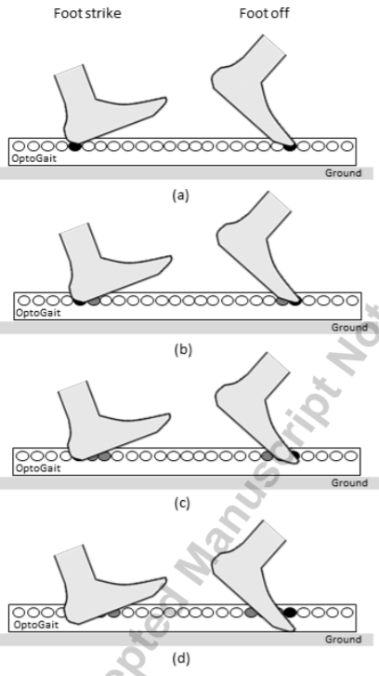

Figure 1 – influence of the settings of led number on the foot contact and off. (a), (b), (c) and (d) respectively have for settings 1, 2, 3 and 4 leds. The change in the foot height is clearly visible. [5]

In conclusion the validity and reliability of the Optogait has been validated against an electronic walkway (Gaitrite), an instrumented treadmill (Zebris) and a motion capture system (Vicon), for healthy patients, patients who undergone unilateral total knee arthroplasty and stroke patients. One of the main drawbacks was the systematic biases for stance and swing time, but this can apparently be solved using the settings available in the Optogait software. Based on this conclusion, it does seem possible to precisely the time of foot contact and off using only the data given by the Optogait.

1. **Work and results**

The objective with this work was to put the data from the motion capture system and the data from the Optogait in common so the gait events would be identified automatically on the whole length of the walkway, so 3 m in this study.

* 1. **Retro-engineering**

In a first time it was necessary to determine which information could be extracted from the Optogait. To do so, a protocol, available in annex, was executed to analyze the raw data extracted from the Optogait software after the acquisition was done. The Table 1 was an example of the result of an acquisition.

Table 1 – Raw files obtained after the execution of the test Error! Reference source not found. during which a box is put on the walkway after the Optogait was started. It generates an object with a length of 12 LED, so an object of around 12,5 cm.

|  |  |  |  |  |  |  |  |  |
| --- | --- | --- | --- | --- | --- | --- | --- | --- |
| TimeStamp | Edge1 Led | Edge1 Status | Edge2 Led | Edge2 Status | Edge3 Led | Edge3 Status | Edge4 Led | Edge4 Status |
| 0 | 0 | FALSE | 288 | FALSE |  |  |  |  |
| 13362 | 0 | FALSE | 267 | TRUE | 268 | FALSE | 288 | FALSE |
| 13371 | 0 | FALSE | 266 | TRUE | 268 | FALSE | 288 | FALSE |
| 13380 | 0 | FALSE | 266 | TRUE | 269 | FALSE | 288 | FALSE |
| 13384 | 0 | FALSE | 266 | TRUE | 270 | FALSE | 288 | FALSE |
| 13388 | 0 | FALSE | 266 | TRUE | 271 | FALSE | 288 | FALSE |
| 13390 | 0 | FALSE | 266 | TRUE | 272 | FALSE | 288 | FALSE |
| 13395 | 0 | FALSE | 266 | TRUE | 273 | FALSE | 288 | FALSE |
| 13397 | 0 | FALSE | 266 | TRUE | 274 | FALSE | 288 | FALSE |
| 13403 | 0 | FALSE | 266 | TRUE | 275 | FALSE | 288 | FALSE |
| 13408 | 0 | FALSE | 266 | TRUE | 276 | FALSE | 288 | FALSE |
| 13411 | 0 | FALSE | 266 | TRUE | 277 | FALSE | 288 | FALSE |
| 13414 | 0 | FALSE | 266 | TRUE | 278 | FALSE | 288 | FALSE |

This data was organized as follow: the first column stored a timestamp corresponding to the number of frames passed since the start of the recording. The sample rate being at 1000 Hz, an event appearing at the timestamp 13362 corresponded to an elapsed time of 13.362 s. It was important to note that there was different ways to start an acquisition: from the software or with an external trigger, such as push button. Depending on the type of trigger, the acquisition did not start at the same time. With an external trigger, it was necessary to click on the “execute” function in the correct window to launch the acquisition. Once it was done, the software was waiting for an external trigger. At the push of the button, the software would process the data received. A second push ends the acquisition. It could seem that data was only recorded at the first push on the button but in reality the recording start at the click on the “execute” function of the software.

The information was then recorded as “edges”. Each edge was a change from uninterrupted LEDs to interrupted LEDs and vice versa, such as in the Figure 2. At the beginning of the acquisition, there was no obstacle between the two bands; the only edges detected were the two extremities of the space of measurement. This space was 288 LEDs long, as there were 3 pairs of emitting/receiving bands with 96 LEDs each.

The Optogait did not record any information unless its state changed. If no obstacle went between the bands, no information was saved. Once an obstacle showed up, with the obstacle in the protocol used being a box, the Optogait record new edges. In the Table 1 the object was not laid on the ground perfectly flat so the space between the edge 2 and 3 gradually increase until the whole box was on the ground.

It is useful to note that the settings made in the software had no influence in the raw data.

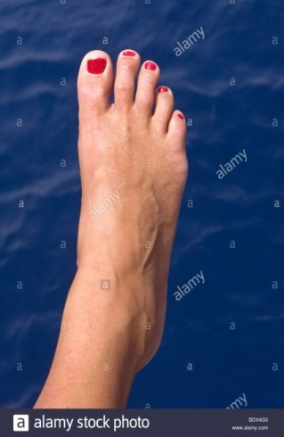

Edge 1

Edge 2

Edge 1

Edge 2

Edge 3

Edge 4

Figure 2 – example of the functioning of the Optogait. Each transition from uninterrupted to interrupt creates an edge.

* 1. **Infrared noise**

Both of the Optogait and Qualisys systems used infrared light. This created a conflict between the two. The emitting band of the Optogait was clearly visible through the infrared cameras. This problem was nevertheless easily fixed thanks to the Qualisys software that proposes capture masks. These masks allowed ignoring certain area in the field of view of a camera. However the Optogait detected the infrareds flashes send by the cameras every 5 ms (as the frames were sampled at 200 Hz in this study). This created an important quantity of noise that had to be treated before using the raw file.

* 1. **Signal treatment**

Before interpreting the measure from the Optogait, the raw file had to be cleaned. To do so, multiples configurations were identified and deleted.

* The theoretical maximum number of detected edges, in the case of a really cavus foot, where the proximal and distal parts of a foot would be detected individually, was of ten. This case was illustrated in the Figure 3. Any lines with more than 10 edges would be deleted.
* A TRUE and FALSE state was associated to each edge. The LED can alternate between those states, without the value of the edge changing. This blinking did not provided any valuable information. To solve this problem, each line was compared with the following line and if the pair was similar, the second line was deleted.
* It was also possible that the Optogait blinks between two states with different number. This case was one of the main artifacts created by the flashes of the Qualisys motion capture system. The lines were compared two by two and if the two pairs were similar, the second line on the total of 4 was deleted.
* After the previous treatments, a continuous files was recreated, all timestamps were recreated based on the available information. Not only were the changes saved in this file, but the information for each sample. This file was easier to manipulate for synchronization and to delete the remaining noises.

2

1

3

4

5

…X2 foot

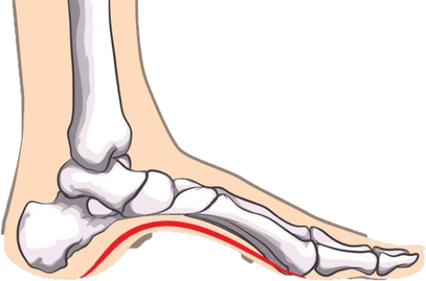

Figure 3 - A cavus foot, the LEDds under the foot are not interrupted and therefore 4 edges are created for one foot.

* Afterward, a function read the number of edge of each line and another function the changes in the number of edges between two frames. A third function detected the quick changes in the number of edges. The user could choose the minimal temporal length of a change to be considered as a real change and not an artifact. For example if a change appears for a time shorter than the chosen threshold, it was considered as an artifact and the line was deleted.
* The number and changes of edges were computed again, and 2 particular cases were addressed. These cases were visible in Table 2 and Table 3.

Table 2 – First specific case, were it was preferable to keep the line 12655 rather than to delete it. The left side of the table is the raw file before treatment and the right side is after treatment.

|  |  |  |  |  |  |  |  |  |  |  |  |  |  |
| --- | --- | --- | --- | --- | --- | --- | --- | --- | --- | --- | --- | --- | --- |
| TimeStamp | E1 | E2 | E3 | E4 | E5 | E6 | TimeStamp | E1 | E2 | E3 | E4 | E5 | E6 |
| 12654 | 0 | 288 | 0 | 0 | 0 | 0 | 12654 | 0 | 288 | 0 | 0 | 0 | 0 |
| 12655 | 0 | 124 | 142 | 199 | 211 | 288 | 12655 | 0 | 124 | 142 | 199 | 211 | 288 |
| 12656 | 0 | 288 | 0 | 0 | 0 | 0 | 12656 | 0 | 124 | 142 | 199 | 211 | 288 |
| 12658 | 0 | 124 | 142 | 199 | 211 | 288 | 12657 | 0 | 124 | 142 | 199 | 211 | 288 |
| 12659 | 0 | 124 | 142 | 199 | 211 | 288 | 12658 | 0 | 124 | 142 | 199 | 211 | 288 |

Table 3 – Second specific case, were the noise created errors on 2 lines. The left part of the table is before treatment and the right part is after treatment.

|  |  |  |  |  |  |  |  |  |  |  |  |  |  |  |  |
| --- | --- | --- | --- | --- | --- | --- | --- | --- | --- | --- | --- | --- | --- | --- | --- |
| TimeStamp | E1 | E2 | E3 | E4 | E5 | E6 | E7 | E8 | TimeStamp | E1 | E2 | E3 | E4 | E5 | E6 |
| 12654 | 0 | 124 | 142 | 199 | 211 | 288 | 0 | 0 | 12654 | 0 | 124 | 142 | 199 | 211 | 288 |
| 12655 | 0 | 124 | 142 | 199 | 211 | 288 | 0 | 0 | 12655 | 0 | 124 | 142 | 199 | 211 | 288 |
| 12656 | 0 | 288 | 0 | 0 | 0 | 0 | 0 | 0 | 12656 | 0 | 124 | 142 | 199 | 211 | 288 |
| 12657 | 0 | 83 | 96 | 179 | 183 | 185 | 189 | 288 | 12657 | 0 | 124 | 142 | 199 | 211 | 288 |
| 12658 | 0 | 124 | 142 | 199 | 211 | 288 | 0 | 0 | 12658 | 0 | 124 | 142 | 199 | 211 | 288 |
| 12659 | 0 | 124 | 142 | 199 | 211 | 288 | 0 | 0 | 12659 | 0 | 124 | 142 | 199 | 211 | 288 |

The steps done after the creation of the continuous file were executed again, in order to have the cleanest files possible for interpretation.

* 1. **Synchronization**

The precision necessary to correctly divide the phase of a gait cycle was of the order of a millisecond. To attain this precision, it was necessary to synchronize the two systems before putting their information in common. To do so multiple methods were tested and were presented in the following paragraph.

* + 1. **Basketball method**

To be able to validate the synchronization and to be able to evaluate an eventual remaining delay, an event common to the Optogait and the Qualisys system was created with a basketball. The ball was released above one of the two force platform available, between the two bands of the Optogait. The impact will create a force peak at the platform and the Optogait have a sample rate high enough to efficiently detect to moment at which the basketball was in contact with the ground, as visible in the Table 4. The information detected by the force platform was illustrated in the Figure 4.

Table 4 – Totality of the information recorded by the Optogait for the impact of a basketball. The rebound itself lasts 6 milliseconds.

|  |  |  |  |  |  |  |  |  |  |
| --- | --- | --- | --- | --- | --- | --- | --- | --- | --- |
| TimeStamp | Edge1 Led | Edge2 Led | Edge3 Led | Edge4 Led | Edge5 Led | Edge6 Led | Edge7 Led | Edge8 Led | Edge8 Status |
| 0 | 0 | 115 | 142 | 195 | 227 | 288 |  |  |  |
| 10640 | 0 | 115 | 142 | 172 | 174 | 195 | 227 | 288 | FALSE |
| 10641 | 0 | 115 | 142 | 171 | 175 | 195 | 227 | 288 | FALSE |
| 10642 | 0 | 115 | 142 | 170 | 175 | 195 | 227 | 288 | FALSE |
| 10644 | 0 | 115 | 142 | 171 | 175 | 195 | 227 | 288 | FALSE |
| 10646 | 0 | 115 | 142 | 172 | 174 | 195 | 227 | 288 | FALSE |
| 10647 | 0 | 115 | 142 | 195 | 227 | 288 |  |  |  |

The impact was detected by both systems and was considered quick and fast enough to generate a valid point of comparison. The total number of edges went up to 8, because of the configuration visible in the Figure 5. The first extremity of the Optogait was the first edge, the right foot generated the edge 2 and 3, the basketball generated the edge 4 and 5 during its rebound, the left foot generated the edge 6 and 7, the edge 8 was the other extremity.

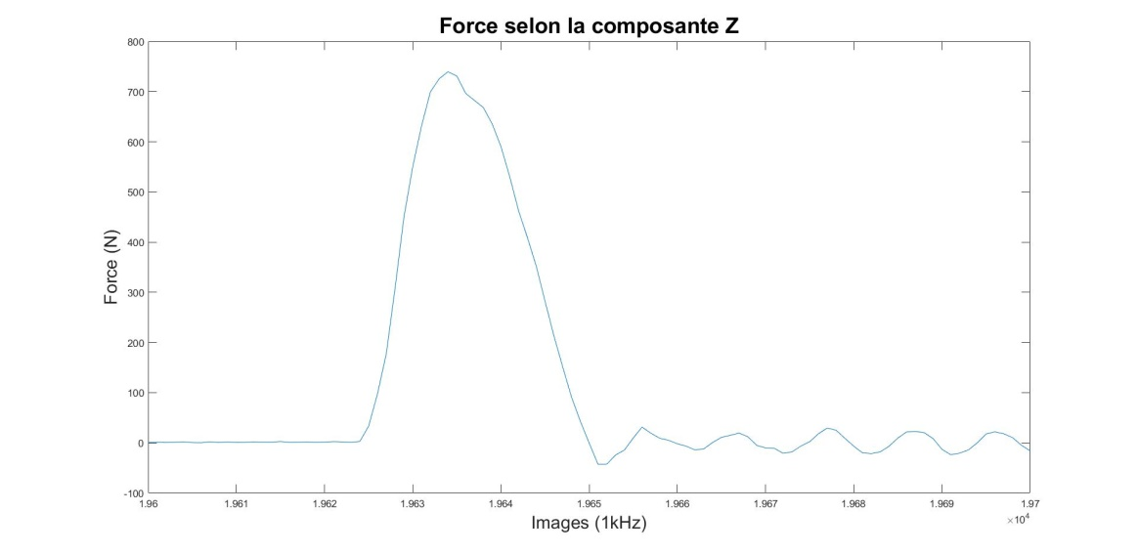

Force following the Z component

Frames (2kHz)

Figure 4 – The force generated by an impact of the basketball.

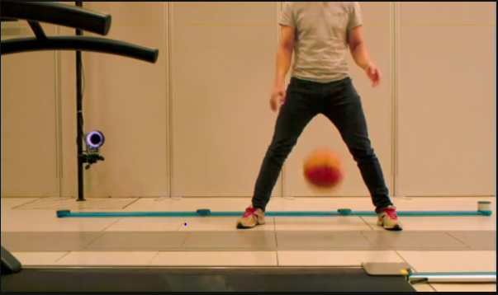

Figure 5 – basketball test configuration.

* + 1. **EMG output**

The Optogait system was equipped with an output exiting square wave of , which changes in tension was meant to match gait events. The purpose of this output was to activate a Functional Electrical Stimulation (FES) device. In reality, there was a latency of 300 ms between the event and the corresponding change in tension, which would not have been a problem if this data had not showed poor reliability and repeatability.

* + 1. **External trigger**

It was possible to start the acquisition by simply pushing a button, which would send a signal to the Optogait triggering the start of the acquisition. The Qualisys cameras were also triggered by this mean. To start both systems simultaneously, the signal send to the cameras was derived towards the Optogait. The hypothesis was that simultaneous start would be precise enough to synchronize precisely the systems, but the delay between different measurements was not constant and showed a standard deviation of 0.06s, way above the desired precision. The delays were presented in the Table 5. This delay could not be corrected with a constant offset possible and therefore invalided this solution for the synchronization.

Table 5 – Delay measured in seconds. Each value is the mean delay for three impacts with the basketball.

|  |  |  |  |  |  |  |  |  |  |  |  |
| --- | --- | --- | --- | --- | --- | --- | --- | --- | --- | --- | --- |
| Test 1 | Test 2 | Test 3 | Test 4 | Test 5 | Test 6 | Test 7 | Test 8 | Test 9 | Test 10 | Test 11 | Standard deviation |
| 0,260 | 0,228 | 0,157 | 0,338 | 0,267 | 0,240 | 0,236 | 0,164 | 0,268 | 0,186 | 0,360 | 0,061 |

* + 1. **On/Off**

The external trigger having a standard deviation too high, it was necessary to find another signal visible by both systems. The explored solution was to turn the emitting band on and off. This created a signal visible for both the receiving band and the cameras. The Optogait captured the information in the Table 6 and the emitting band was visible directly on the field of view of the cameras in front of it.

Table 6 – The emitting band was turned off during approximately 10 s, duration that was found between the second and third line.

|  |  |  |  |  |
| --- | --- | --- | --- | --- |
| TimeStamp | Edge1 Led | Edge2 Led | Edge3 Led | Edge4 Led |
| 36489 | 0 | 288 |  |  |
| 36492 | 0 | 288 |  |  |
| 46928 | 0 | 204 | 205 | 288 |
| 46933 | 0 | 204 | 206 | 288 |

The mean delay of this solution was of , with a standard deviation of . The results used to produce this value were in the Table 7. They were well within the needed precision, but this solution needed an important involvement of the rater. He had to get up, execute the on/off sequences by directly turning the emitting side of the Optogait by using the on/off switch button, launch the motion capture acquisition, before ratings manually the frames were the Optogait turn on and off in the software Qualisys Track Manager. These steps needed to be repeated for each session, which would necessitate too much work for the rater.

Table 7 –Results of the on/off synchronization, with AVG meaning average, STD meaning standard deviation. The values are expressed in seconds. 4 acquisitions with 3 on/off sequence were used.

|  |  |  |  |  |
| --- | --- | --- | --- | --- |
| synchro on off | | | AVG | STD |
| -0,00109 | 0,000866 | 0,001822 | 0,00053 | 0,001 |
| -0,00182 | -0,00185 | -0,0014 | -0,0017 | 2E-04 |
| 0,000707 | 0,000691 | 0,000637 | 0,00068 | 3E-05 |
| -0,00423 | -0,00365 | -0,00356 | -0,0038 | 3E-04 |
| Total | | | -0,0011 | 0,002 |

1. **Arduino based solution**

Based on the results of the previous test, it was decided to pursue in the philosophy of the last solution. Instead of turning on and off the emitting band, a LED precisely controlled would permits to obtain a higher precision and facilitate the detection of synchronization signals. Due to its versatility and to its ease of use, it was decided that the LED would be controlled with an Arduino board, in this study an Arduino Uno.

* 1. **Setup**
     1. **Qualisys**

A ten-camera Qualisys Motion Capture System was used in this study. It was used with the designated software Qualisys Track Manager. The system was set so the beginning and the end of the acquisition was controlled with the use of an external trigger.

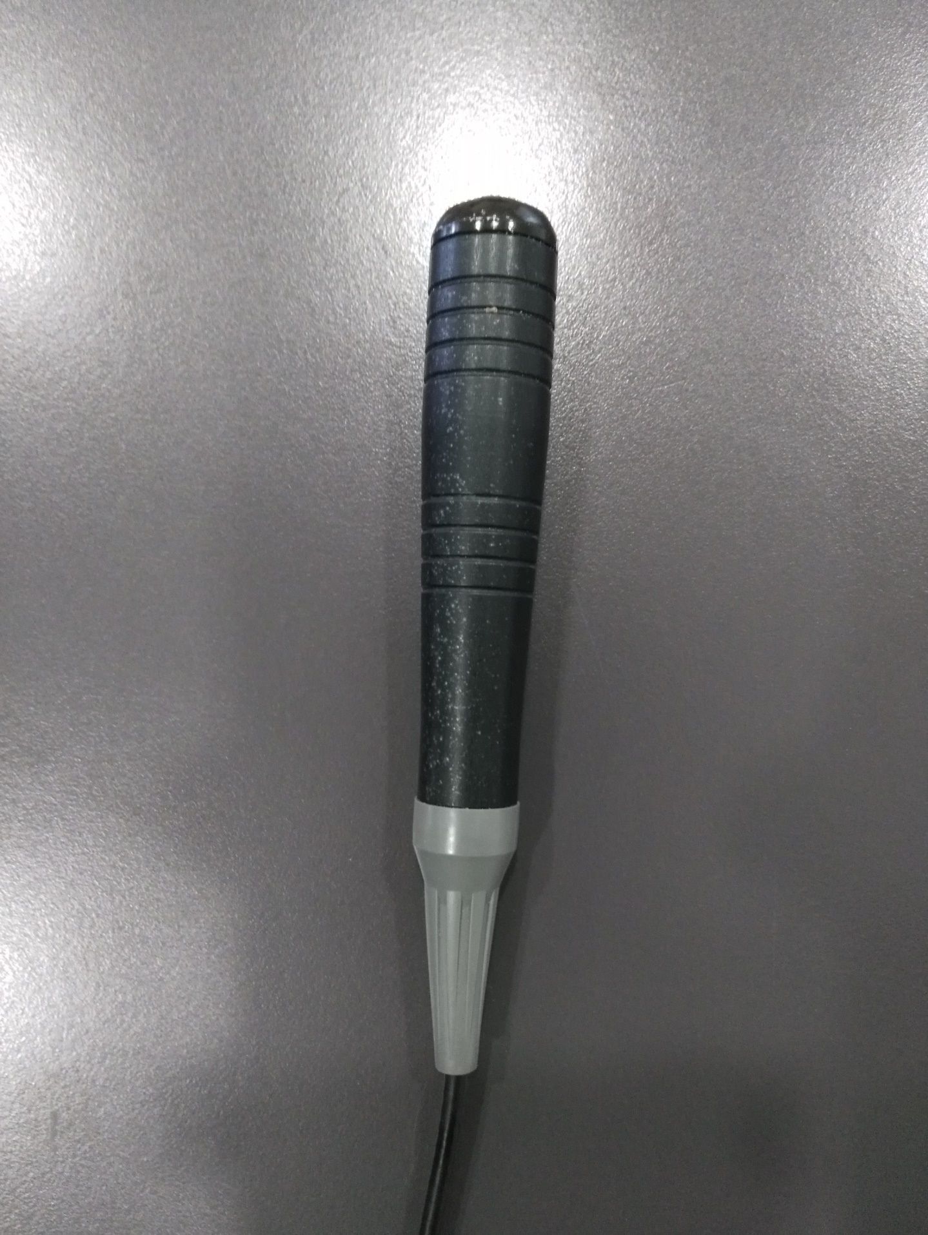

Figure 6 – The external trigger used to control the starting and ending points of the acquisition. It is connected to the master camera.

* + 1. **Optogait**

The acquisition for the Optogait can be controlled through the designated software but it is also possible to use an external trigger. The aim of the work done for this publication was to synchronize the two systems, so the same signal was used to trigger the Qualisys and the Optogait. To do so the signal going to the master camera was simply derived using a T connector. One extremity of the cable connected to this T was a BNC connector. The other extremity was composed by two banana connectors, visible in the Figure 7.

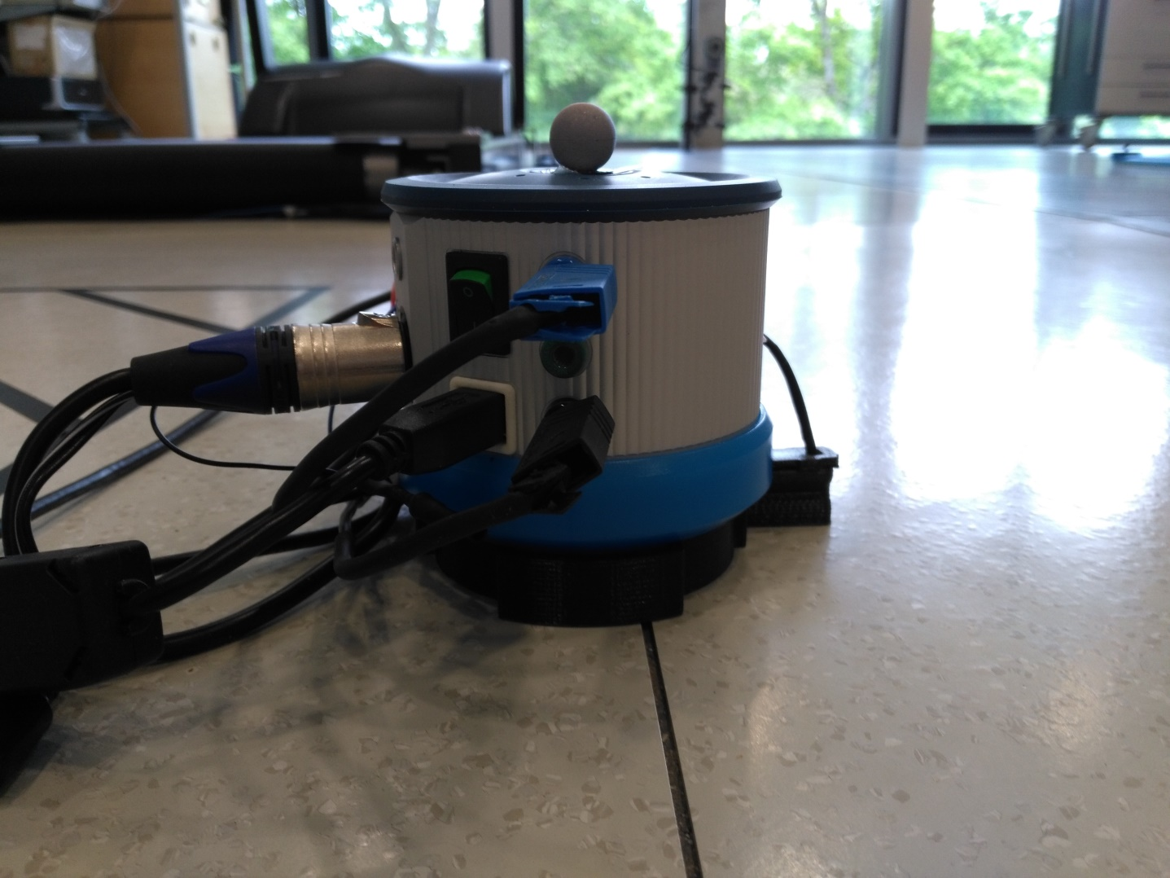

Figure 7 – Port used to start and stop the acquisition. The blue port is positive and the black one is negative.

* 1. **Wiring and components**

The wiring used is simple and necessitates only few components, shown in

* 1 LED with a wavelength of 890nm, to interact with the Optogait.
* 2 resistors of 180Ohms, one to limit the current to the LED, the other before the entry to the analogic entries of the MOCAP rig.
* A diode between the positive cable transmitting the trigger to the Optogait and the analogic entry of the Arduino.
* The Arduino board itself.

The LED is connected to the output D13, but could be connected to any output as long as the code is modified appropriately. The negative side is connected to the closest ground. The output D12 is connected to the analogic entry of the motion capture system. The negative side is connected to another ground to facilitate the connection. The input A0 is connected to the positive trigger cable going to the Optogait.

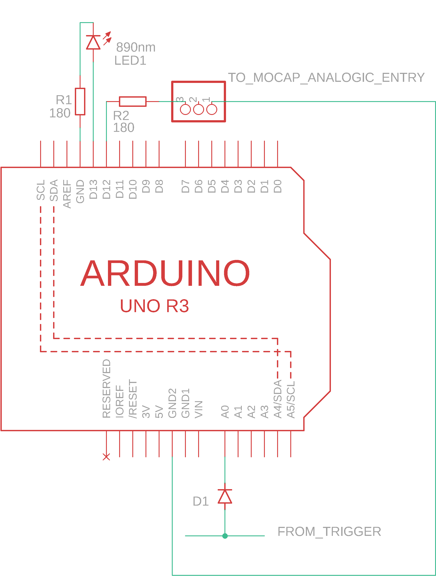

Figure 8 – Wiring drawings of the components used.

* 1. **Linked** **Arduino** **program**

The principle used was to send a signal to both of the systems and to use this signal to synchronize the systems. Square waves with a height of 5V were sent to the mocap system and the LED will blink at a given frequency during a given time. The signal will start with the same trigger as the Optogait and mocap systems.

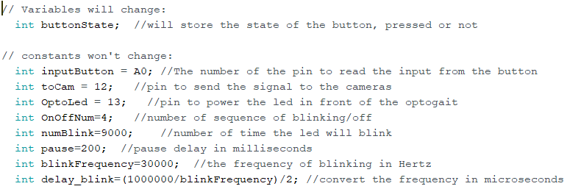

All the variables were declared. This is where the inputs and outputs port were selected. The input for the trigger signal was put on the analogic port A0 because the use of a digital was not reliable. The tension of the signal coming from the trigger was different from zero but would not always be higher than 3.0V, which was the tension required from the Arduino to read an HIGH state. Therefore using a digital pin was not possible; even if the tension changed when the button was pushed, the state will stay at LOW. On the contrary it was observed that when the button was pushed, the tension would go down to 0.

As the output would only have to change from HIGH to LOW states, two digital pin were used, the D13 to control the LED and the D12 to send information to the mocap system.

The OnOffNum variable stored the number of times that the synchronizing signal will be send. In this case the variable is equal to 4, meaning 4 waves will be sent to both of the systems.

The numBlink variable will store the number of times that the LED will turn on and off to blink. This variable is linked to the blinkFrequency variable and the delay_blink variable. The blink frequency was selected by empirical testing. The frequency of the LED is announced at 1000Hz by the Optogait constructor, but it was observed that a frequency around 30kHz gave better results in the detection of the signal. The delay_blink variable will translate the frequency in time intervals. If the led blink 9000 times, with a frequency of 30kHz, the LED will blink during 0.3 seconds. The blinking phase then stops during a time equal to pause, or 0.2 seconds in this case. These times can be visualized in the square waves sent to the analogic input of the mocap system on the Figure 9. The number of waves sent to synchronize the systems was set to 4.

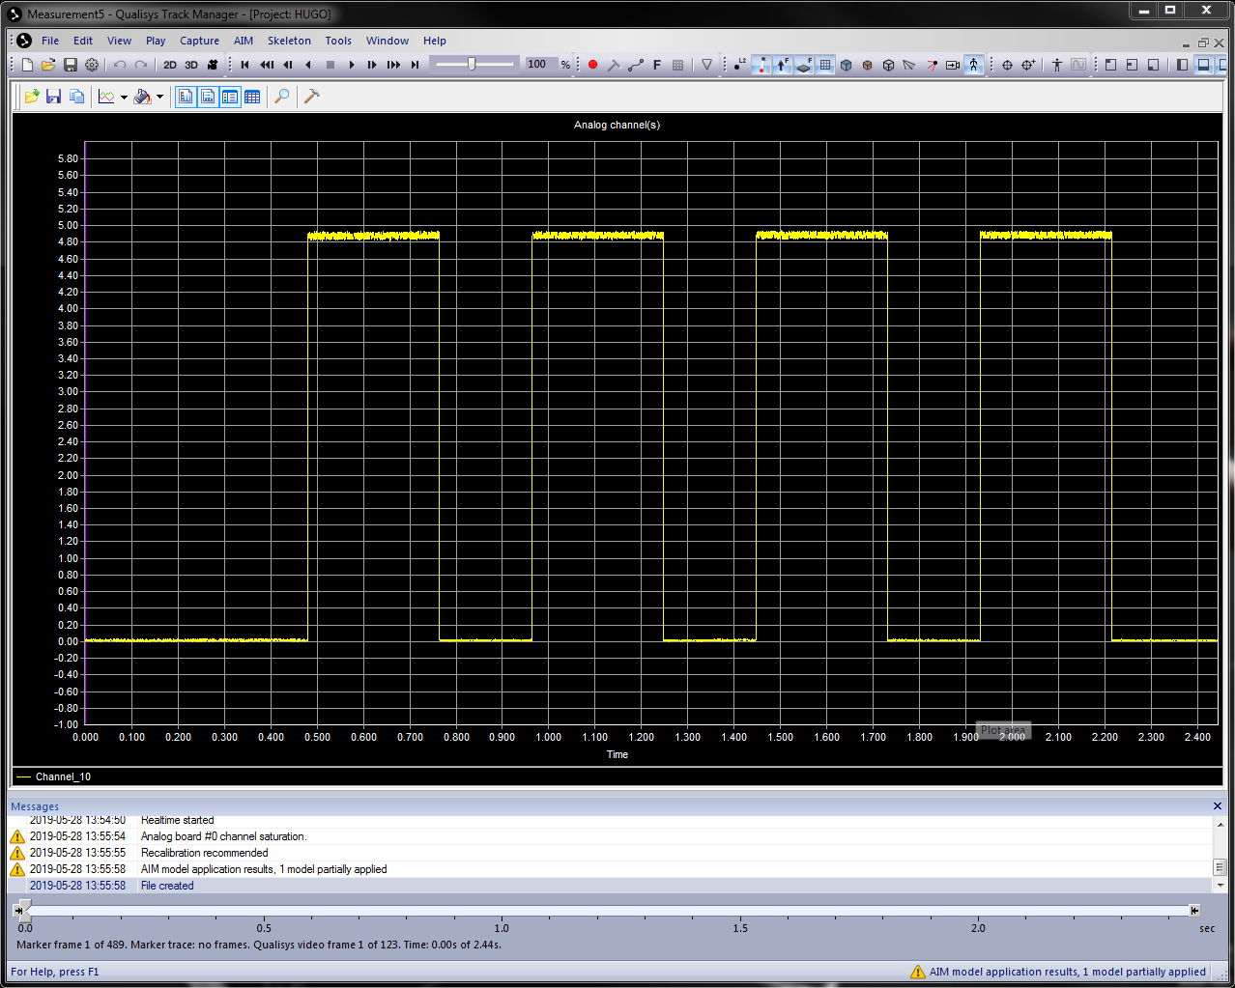

**B**

**1**

**2**

**3**

**4**

**A**

Figure 9 – A : The digital output is set to HIGH and the LED will blink during 300ms; B : the digital output is set to low and the LED stop blinking for 200ms. It is repeated 4 times.

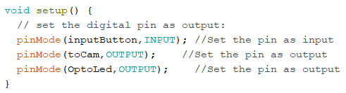

The pins are set up as input or outputs. The pin inputButton used to read the state of the button is logically set as input, while the pin used to send signals towards the Optogait and mocap systems are set as outputs.

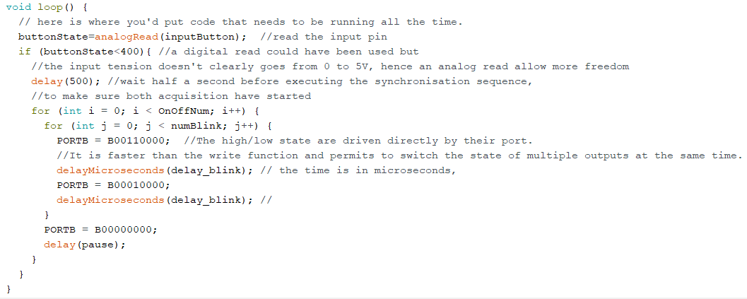

The main loop starts by reading the button state. The input used is an analogic one, so the value can go from 0 to 1084. In this study the value of the input would go down to exactly 0 when the button was pressed, and would be around 500 when it was not. This make the use of a digital input less reliable than the solution used here. If the analogic value of is strictly smaller than 400, the synchronization is initiated.

The first action was actually a delay, set at 500ms. The program would wait so it was sure that both of the systems have launched their acquisition and were recording.

Once the delay passed, two intricate loops would start. The first one would choose the number of waves sent to the systems. The second one will set the analogic input of the mocap to HIGH and will made the LED blink. To do so the outputs are driven directly by their port, to avoid the use of the write function. This function will take a certain time to execute, setting off the desired timings and allows to modification of only one output at the time. The third zero from the left corresponds to the pin 13, the fourth to the pin 12. First both of the pin are set to high, then the pin 13 is set to low after waiting for 16µs, then set to high again for as many cycle as numBlink. Once the loop is done, both of the outputs are set bake to LOW. This loop will execute again for as many times as the variables OnOffNum states.

Once the whole loop is executed, it will go back at the beginning were it would wait for another push of the button.

* 1. **Data acquisition**

Once the synchronization done, it was possible to time events. In a first time a healthy patient walked back and forth on the walkway, at a comfortable pace. He then imitated pathologies, concentrating on the behavior of the feet. The type of gaits where the following:

* Healthy: the patient walked normally at a comfortable pace.
* Equinus: the patient imitated an equinus gait. The contact was initiated with the front of the foot, the heel did not touched the ground during the stance phase and the foot off was executed normally.
* Steppage gait: the patient imitated a steppage gait, where the stop of the forward motion was not coincident with the contact with the ground. At foot contact, the foot motion was more vertical. The foot off was executed normally.
* Drag: the patient showed a poor foot clearance at foot off, dragging its toe or medial forefoot across or near the walkway.
* Small step: the patient executed really small steps, with a really small step length, so that one foot did not cleared the length of the other foot.

The number of events for each type of gait was displayed in the Table 9.

Table 9 - Number of events for each type of gait

|  |  |  |  |  |  |  |  |  |  |
| --- | --- | --- | --- | --- | --- | --- | --- | --- | --- |
| Healthy | | Equinus | | Steppage | | Drag | | Small step | |
| Contact | Off | Contact | Off | Contact | Off | Contact | Off | Contact | Off |
| 25 | 19 | 15 | 16 | 4 | 4 | 5 | 5 | 6 | 4 |

Due to the type of pathology used, not all of the events were determined with the same technique. The events of the Healthy, Equinus and Steppage gait were determined with the classic Gold Standard, the force platform. A threshold of 10N was used for foot contact and off. For the drag gait, the foot off was rated by an operator, and was considered as the moment of the start of the forward motion of the hallux marker. For the foot contact the force platform was used with the same threshold. For the small steps, the foot contact was timed at the stop of the forward motion of the hallux marker, the foot off was determined like for the drag gait.

For the gaits with floor clearance, the Healthy, Equinus and Steppage gait, the event detection was based on the number of LEDs interrupted. For a foot contact, the data displayed in Table 10 was used. For the threshold of 2 LEDs, the timing corresponds to the time when an object with a size of at least 2 LEDs appeared. When an object 3 LEDs long appeared the timing was recorded the same way, up to 5 LEDs. It was sometime necessary to go further than 5 LEDs to approach the Gold Standard. The errors were computed and the best threshold was determined.

Table 10 – Data used to determine the best threshold and the errors of the event detection by the Optogait.

|  |  |  |  |  |  |
| --- | --- | --- | --- | --- | --- |
| Left foot Contact | | | | | |
| Material | Optogait | | | | Force plate |
| Threshold (LEDs/Force) | 2 | 3 | 4 | 5 | 10N |
| Timing (Frames,200Hz) | 2904,2 | 2904,8 | 2905 | 2906,2 | 2906 |
| Absolute errors (Frames) | 1,8 | 1,2 | 1 | 0,2 |  |
| Best threshold | 5 |  |  |  |  |
| Best error | -0,2 |  |  |  |  |
| Threshold LED=4 | 1 |  |  |  |  |
| Threshold LED=5 | -0,2 |  |  |  |  |

For timings for foot off were determined the same way, but with a descending threshold: when the size of an object was under the threshold, the timing was recorded. The data extracted with these methods were presented in the Table 12.

For the gait types without foot clearance, the moments of beginning or stops of forward motion were determined by looking at the edge of the objects. For the drag and small step gaits, foot off events were detected when the posterior edge started to change and foot contact were detected when the anterior edge stopped going forward.

* + 1. **Results**
       1. **Synchronization**

By comparing this synchronization with the impacts made by the basketball, the delays in the Table 11 were computed.

The low mean and the low standard deviation demonstrate the reliability of this solution. The maximum error encountered was of 0.0052, which correspond to approximately 1 frame for cameras sampled at 200Hz, which was clearly in the limits of actual algorithms.

Table 11 – Results of the synchronization tests, with three impacts for each of the ten tests. “AVG” mean average and “STD” means standard deviation. The results are expressed in ms.

|  |  |  |  |  |  |
| --- | --- | --- | --- | --- | --- |
| test n° | impact 1 | impact 2 | impact 3 | AVG | STD |
| 1 | 0,0041 | 0,0040 | 0,0043 | 0,0041 | 0,0001 |
| 2 | 0,0015 | 0,0018 | 0,0006 | 0,0013 | 0,0005 |
| 3 | 0,0023 | 0,0021 | 0,0018 | 0,0021 | 0,0002 |
| 4 | -0,0001 | -0,0002 | 0,0001 | -0,0001 | 0,0001 |
| 5 | 0,0015 | 0,0014 | 0,0017 | 0,0015 | 0,0001 |
| 6 | 0,0052 | 0,0030 | 0,0028 | 0,0037 | 0,0011 |
| 7 | -0,0022 | -0,0019 | -0,0016 | -0,0019 | 0,0002 |
| 8 | -0,0037 | -0,0028 | -0,0020 | -0,0028 | 0,0007 |
| 9 | -0,0005 | -0,0002 | -0,0009 | -0,0005 | 0,0003 |
| 10 | -0,0010 | -0,0006 | -0,0011 | -0,0009 | 0,0002 |
| Total | | | | 0,000819 | 0,002288 |

* + - 1. **Event timing**

The results from the hybrid approach for the healthy gait were presented in the Table 12. First a best LED threshold for foot contact and off was computed, by doing the average of the thresholds resulting in the smaller error for each event. The average error was computed for this setting. Then the error and standard deviation was computed with thresholds settings around the average of the best thresholds: the average of thresholds for the contact was 4.68 frames; hence errors were computed with thresholds of 4 and 5 frames. The same was made for the foot off.

Table 12 – Results of the use of the Optogait to detect events in healthy gait. “avg” means average, “STD” means standard deviation.

|  |  |  |  |  |
| --- | --- | --- | --- | --- |
| Walk type : Healthy | | | | |
| Threshold | | | | |
| avg threshold contact | | 4,680 | STD | 0,466 |
| avg threshold off | | 2,200 | STD | 0,653 |
| Errors with best thresholds | | | | |
| avg contact error | | 0,208 | STD | 0,394 |
| avg off error | | -0,074 | STD | 0,659 |
| Errors with thresholds: | | | | |
| Contact | 4 | Off | | 2 |
| avg contact error | | 0,864 | STD | 0,511 |
| avg off error | | -0,300 | STD | 0,694 |
| Errors with thresholds: | | | | |
| Contact | 5 | Off | | 3 |
| avg contact error | | -0,184 | STD | 0,700 |
| avg off error | | 0,211 | STD | 0,932 |

Considering the small events sets for other types of gaits, the errors were only computed with the best results, as the errors with other thresholds were not relevant.

Table 13 – Results for equinus gait

|  |  |  |  |
| --- | --- | --- | --- |
| Equinus | | | |
| Thresholds | | | |
| avg threshold contact | 6,800 | STD | 0,909 |
| avg threshold off | 2,625 | STD | 0,857 |
| Errors with best thresholds | | | |
| avg contact error | 0,356 | STD | 0,417 |
| avg off error | 0,212 | STD | 0,887 |

Table 14 – Results for steppage gait

|  |  |  |  |
| --- | --- | --- | --- |
| Steppage | | | |
| Thresholds | | | |
| avg threshold contact | 7,250 | STD | 1,090 |
| avg threshold off | 2,750 | STD | 1,299 |
| Errors with best thresholds | | | |
| avg contact error | 0,550 | STD | 0,357 |
| avg off error | -1,025 | STD | 1,308 |

Table 15 – Results for drag gait

|  |  |  |  |
| --- | --- | --- | --- |
| Drag | | | |
| Thresholds | | | |
| avg threshold contact | 11,200 | STD | 5,741 |
| avg threshold off | 2,200 | STD | 0,400 |
| Errors with best thresholds | | | |
| avg contact error | -0,600 | STD | 0,490 |
| avg off error | -1,600 | STD | 2,132 |

Table 16 – Results for small step gait

|  |  |  |  |
| --- | --- | --- | --- |
| Small steps | | | |
| Thresholds | | | |
| avg threshold contact | 1,571 | STD | 0,904 |
| avg threshold off | 9,000 | STD | 3,082 |
| Errors with best thresholds | | | |
| avg contact error | -0,800 | STD | 4,261 |
| avg off error | -1,050 | STD | 3,278 |

* + 1. **Discussions**

The Table 12 shows results with errors under the frame and with a low standard deviation, illustrating the reliability of this solution for healthy patients. With thresholds of 5 LEDs for foot contact and 3 LEDs for foot off, the error in the detection of foot contact compared to the Gold Standard was in average of -0.184 frames, the foot off error was of 0.211 frames. It was equivalent to -0.92ms and 1.055ms for foot contact and off respectively. It was well within the range of other motion based algorithm, with the simple use of LEDs threshold.

These values of threshold verified the effect of the geometry previously described in other publications [28,30]. When the heel of foot enters in contacts with the ground, 4 to 5 LEDs were already interrupted. Using a smaller threshold would mean detecting the event before the foot actually touches the ground, as illustrated in the Figure 8. For the toe off, moment where the foot was not anymore detected by the Optogait practically coincide with the moment of toe off detected by the Gold Standard, the effect of the geometry was less important.

For Equinus, Steppage and Drag gait, (Table 13, Table 14 and Table 15) the foot contact thresholds were significantly higher. It was explained by how the feet approached the ground. For Equinus, the feet approached the ground with the front part of the foot, in a more vertical motion and with more length. It resulted in a higher threshold. This effect was amplified for the steppage and drag gait. For both of these groups, the motion was mainly vertical at the foot contact and the contact was made with a flat foot, increasing the number of LEDs activated before the true foot contact. The errors for foot contact and off stayed reasonable, especially for Equinus and steppage Gaits. The high standard deviation for Drag and small steps gait may be explained by the small size of the sample, but it was also a sign of a smaller reliability.

The foot off average threshold was consistent across Healthy, Equinus and Steppage groups, with the disappearance of the foot of the Optogait corresponding to the event detected by the Gold Standard.

For Drag and small steps groups, the methods used to detect foot off was less effective and results in thresholds with higher standard deviations.

1. **Conclusion and perspectives** 
   1. **Proposed hybrid approach**

The two systems were effectively put in communication and it was possible to inject the information of the Optogait directly into a .c3d file, in the form of markers takings high or low positions, as shown in the Figure 27. In a first time, this information can be used by a biomechanics team as additional data to improve event rating, especially for events outside force platforms. Even considering the Optogait’s geometry, with the correct threshold, this method proved to be reliable and easy to use for healthy, equinus and steppage groups. It has a high potential for automation, which could ease the rater’s work even further.

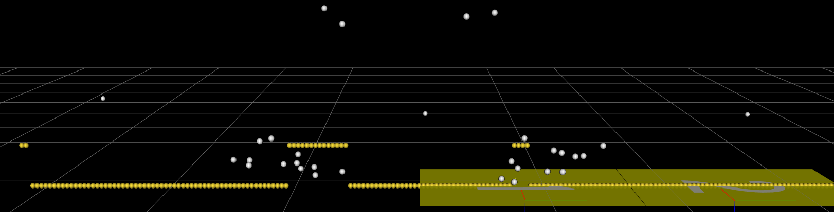

Figure 27 – The markers representing the information of the Optogait are in yellow, a high state means that the light ray is interrupted.

For more challenging gaits, such as drag and small step, it was harder to correctly time the events given the information used, but it still useful as additional data and could be automatized with the correct algorithm.

Concerning the installation of the device, it was easy once the design was settled, as it was not necessary to modify any of the existing components in the laboratory. It could also be easy to spread, as it was based on an Arduino and on simple components, materials easy to access. The low price was also an argument in favor of this Arduino-based solution.

[1] Lienhard, K., Schneider, D., and Maffiuletti, N. A., 2013, “Validity of the Optogait Photoelectric System for the Assessment of Spatiotemporal Gait Parameters,” Medical Engineering & Physics, **35**(4), pp. 500–504.

[2] Lee, M. M., Song, C. H., Lee, K. J., Jung, S. W., Shin, D. C., and Shin, S. H., 2014, “Concurrent Validity and Test-Retest Reliability of the OPTOGait Photoelectric Cell System for the Assessment of Spatio-Temporal Parameters of the Gait of Young Adults,” Journal of Physical Therapy Science, **26**(1), pp. 81–85.

[3] Shin, S., 2014, “Agreement between the Spatio-Temporal Gait Parameters from Treadmill-Based Photoelectric Cell and the Instrumented Treadmill System in Healthy Young Adults and Stroke Patients,” Medical Science Monitor, **20**, pp. 1210–1219.

[4] Gomez Bernal., A., Becerro-de-Bengoa-Vallejo, R., and Losa-Iglesias, M. E., 2016, “Reliability of the OptoGait Portable Photoelectric Cell System for the Quantification of Spatial-Temporal Parameters of Gait in Young Adults,” Gait & Posture, **50**, pp. 196–200.

[5] Healy, A., Linyard-Tough, K., and Chockalingam, N., 2018, “Agreement Between the Spatiotemporal Gait Parameters of Healthy Adults From the OptoGait System and a Traditional Three-Dimensional Motion Capture System,” Journal of Biomechanical Engineering, **141**(1), p. 014501.